Assignment #3
Due: 1 pm, Wednesday, March 4th

Issue: Student success in their first year is a strong predictor of subsequent degree success. Students experiencing difficulty in first year have a high likelihood to not return for their second year. Interventions to assist at risk students must occur early in the first year if they are to be effective. Ideally, they should start in the first two months of the fall term. This is before the first midterm results are available. Can we identify who will be unsuccessful (or successful) before classes even start?

Questions: What is success for a new student? Getting a GPA above 2.00? Keeping your entrance scholarship? Performing above average compared to similar peers?

What data is available? We will limit attention to data that is captured in Banner. In recent years, we have received electronic transcripts for all Nova Scotia high school applicants raising the possibility of knowing student performance, by course, as far back as grade 10. However, for this study, we will look at admissions data from 2015, before these transcripts were available.

For applicants from Canadian high schools, the high school average (out of 100) was recorded at the time of the admission decision. The average was based upon the 5 courses used for the admission decision. If the admission decision was made in the fall while the student was in grade 12, the average was based upon final grade 11 grades. If the decision was made later, it could include some final or mid-year grade 12 course grades.

Exclusion: High school average data for international students is inconsistent, so we will restrict analyses to Canadian students only. Many new students are transferring from colleges or universities. This is a very diverse student population for whom high school data may not be available or may not be a good predictor of success. We will not include these applicants in this study. Identifying potentially unsuccessful international or transfer students should be addressed in separate studies.

Other admission data includes the date of application and the date of the admission decision, the name of the high school and the province in which it is located, and the student’s program of study. Note that admission requirements vary among Arts, Business, Science and Engineering, so the courses included in the high school average will be different. Similarly, the recommended mix of first year courses varies by program.

The extract occurred in January 2016 and included only those students admitted for September 2015. The fall GPA was recorded for each student.

Exclusion: Some new students drop out during the fall term. Some register but never actually attend. These students will show with no earned credits and a GPA of zero. We will consider them as a distinct population of students that should not be included in this study. We will delete all students with a fall GPA of zero. This action deletes students who were active in the fall but failed all courses. As such, some valid records have been deleted, but there was no way to identify these students separately from those who simply disappeared.

In addition to the above “data cleaning”, several variables have been recoded. It is impossible to look at individual high schools, but this information was used to distinguish between students from the Halifax region and those from elsewhere in Nova Scotia. Sample sizes from many provinces outside Nova Scotia are small, so they have all been grouped together as Out of Province (OOP). Similarly, because of the small sample sizes, Engineering students have been merged with Science students and Environmental Studies with Arts.

Although significant data preparation has been done, you will need to do more data preparation to complete assignments 3 and 4. Some will be necessary to answer the questions posed and some will be needed to conform to the way Excel does data analysis.

- a) Rather than simply define “success” in terms of GPA, let us define it in terms of the consequence of high or low GPA. If GPA exceeds 3.70, then a student’s scholarship will be renewed or the student will be eligible for a scholarship. However, if the GP is below 2.00, then the student may be placed on probation. Construct the look up table below in the Look Up Table tab of the file GPA and High School assignment 3.xlxs.

GPA | Success
0 | Probation
2.0 | Satisfactory
3.7 | Scholarship

Insert a column to right of GPA and call it Success. Use VLOOKUP to assign success values based upon GPA.
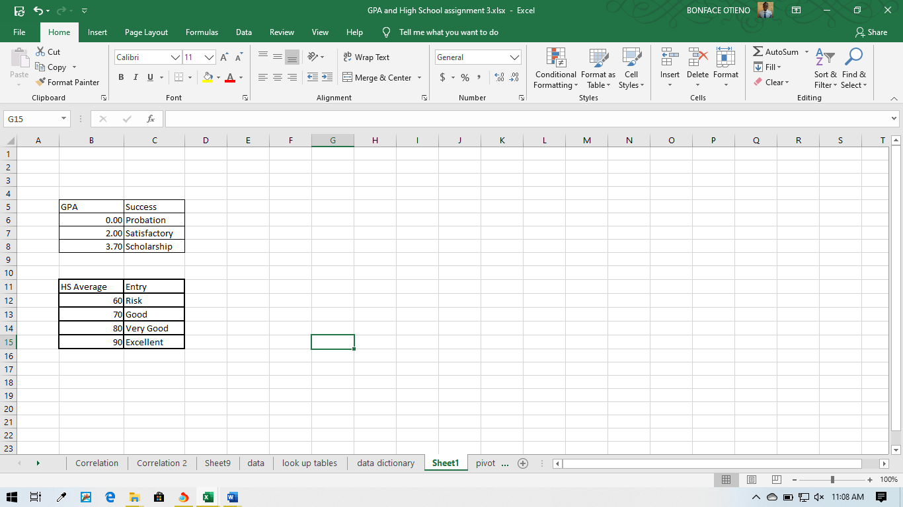

b) Similarly, let us recode the high school average according to the following look up table:

HS Average | Entry
60 | Risk
70 | Good
80 | Very Good
90 | Excellent

Put the above table in the Look Up Table tab. Insert a column to the Right of Success and call it Entry. Use VLOOKUP to assign values to Entry based upon HS Average.

c) Print a screen shot showing the new columns.
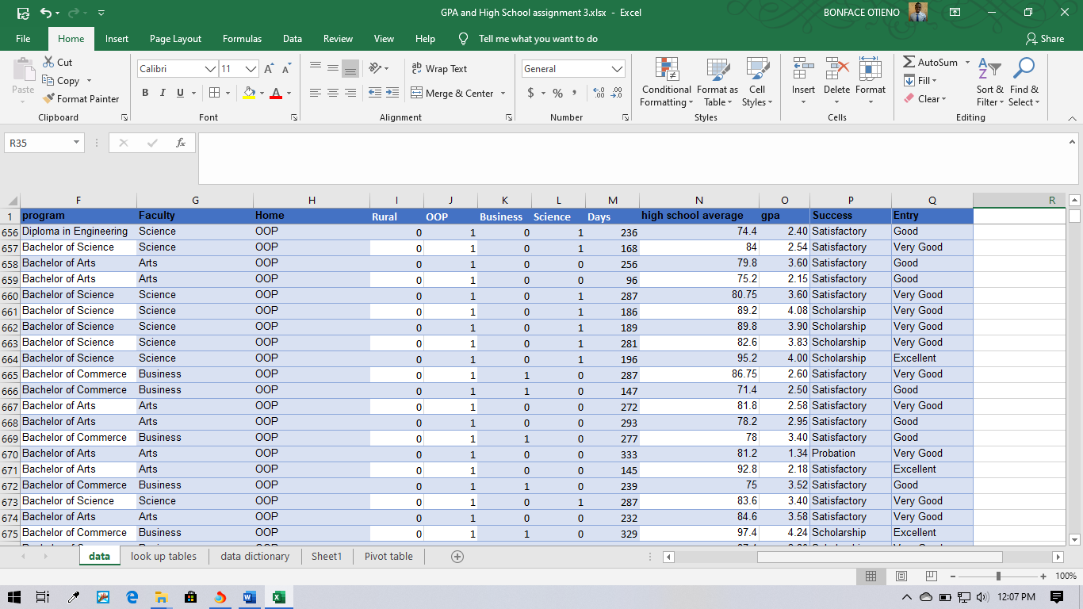

d) Save your file and insert a Pivot Table.

- Let us look at what “success” is like by program. In your Pivot Table, pull Faculty to the Rows and Success to the columns. Pull ID to the Values box. Change the summary to Count and Show Values to Percent of Row Total. This will show you the percentage of students in each program who achieve each level of success.
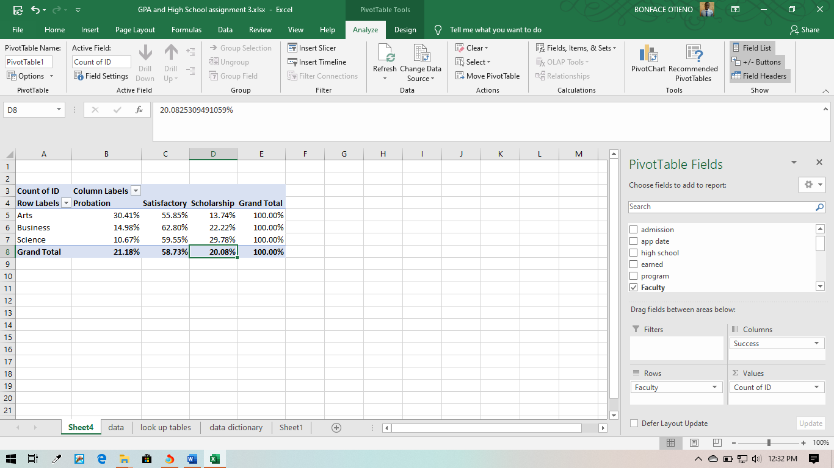

- What percentage of Science students are “Scholarship” students? 29.78% What percentage of Arts students are Scholarship students? 13.17%
- What percentage of Science students are at risk of probation? 10.67% What percentage of Arts students are at risk of probation? 30.41%
- You would think that Science is more demanding than Arts. Why do you think Science is so easy? Because a high percentage of students performed better in science and will get more scholarships than art.
- Let us look at what students look like on admission. In the Pivot Table, drag Success out from the columns and drag Entry in. The table likely shows entry performance in a sequence that is not best to worst. Rearrange the columns by moving labels. Print a copy of your table with columns arranged correctly.
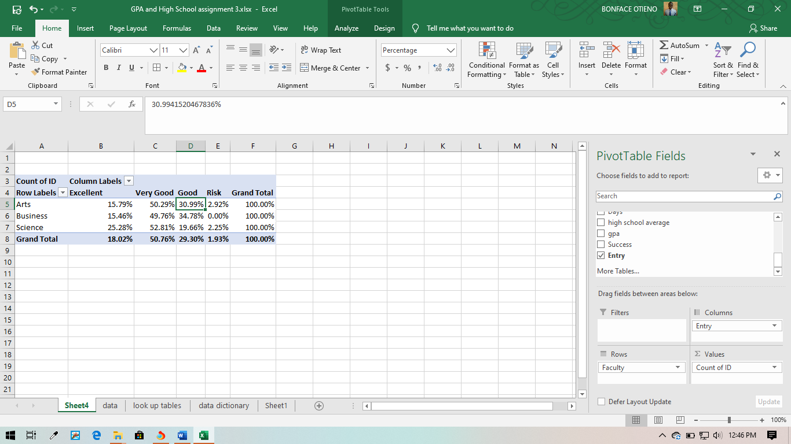
- What percentage of science students were excellent or very good? 25.28% and 52.81% What percentage of Arts students were excellent or very good? 15.79% or 50.29%
- It looks like Science attracts stronger students and they do better than Arts students. Let us look at the distributions as a whole. Construct a Box and Whisker chart for GPA. In Chart Design, and Select Data, Edit the horizontal axis to show Faculty. Print the Box and Whisker chart for Arts, Business and Science. This should be a single chart showing all three faculties. Comment on the differences. Are they as clear as what you found in 3?
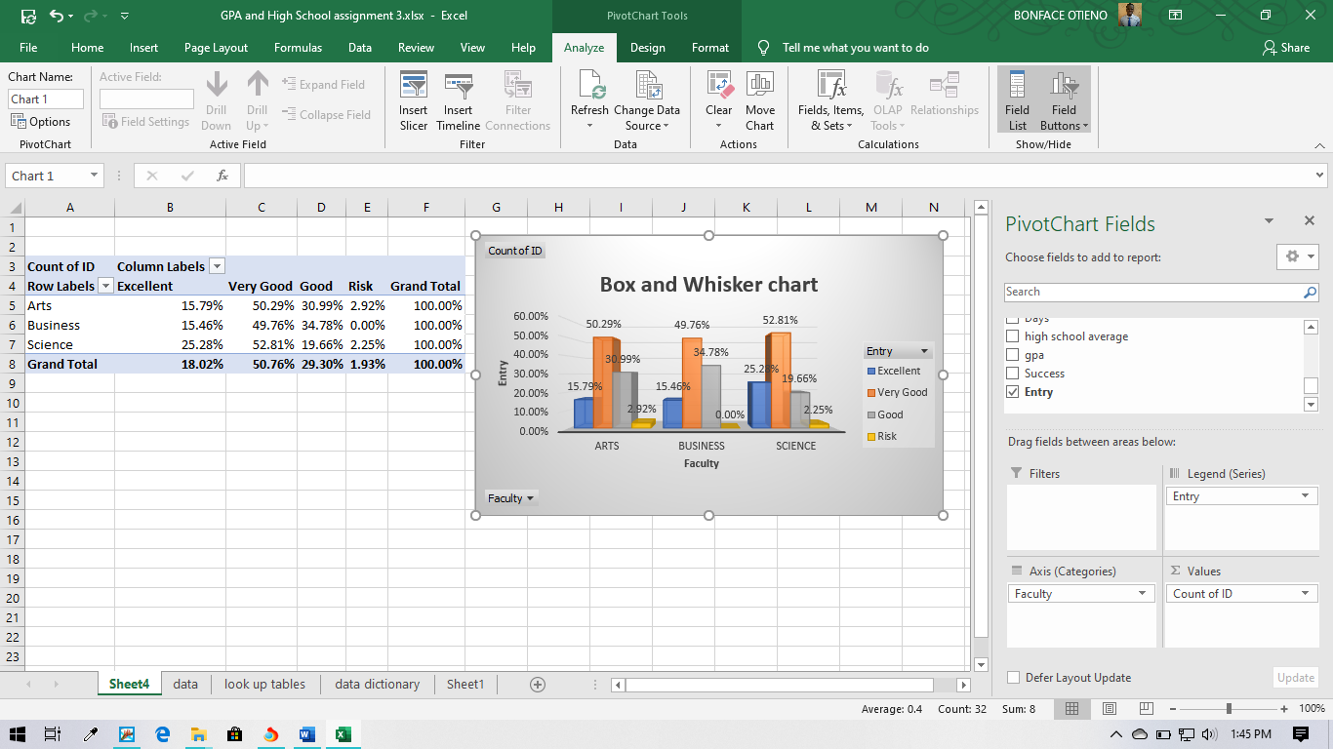
- And what about how they look on admission. Construct a Box and Whisker chart of HS Average and then break it down by Faculty as done in 5. Print the Box and Whisker chart for Arts, Business and Science. Are the differences as clear as you saw in 4? 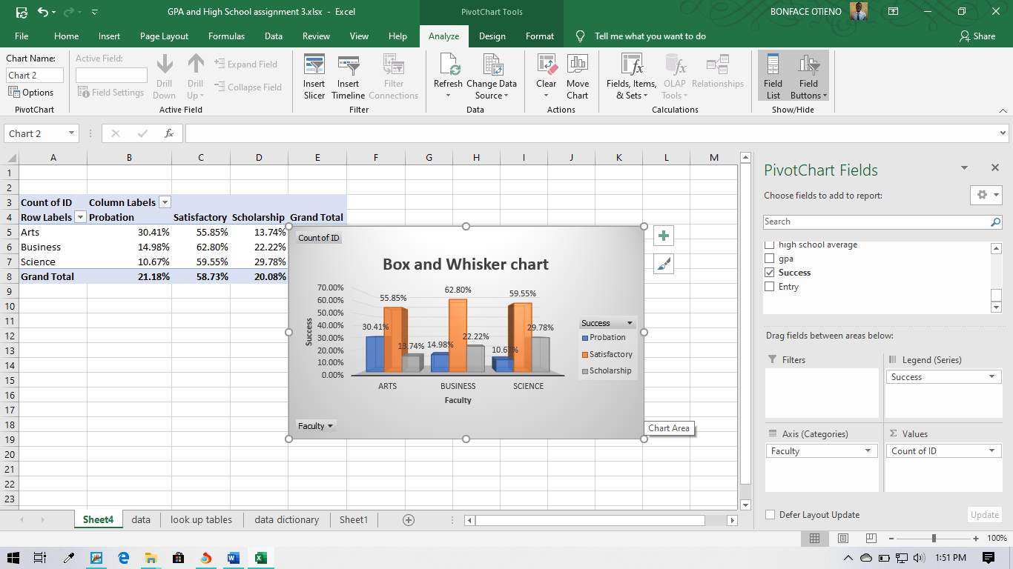
- Box and whisker charts hide unnecessary clutter but can still mask patterns that can emerge from grouping data – less detail can show more. Nonetheless, we feel that Science attracts better students and Science students do better. Let us look at high school grades versus GPA directly, without looking at program. Construct a Scatter Chart of GPA versus HS Average. Excel puts the variable in the left column on the vertical axis and the one in the right column on the horizontal axis. Right click on the horizontal axis and Format Axis such that the minimum is 60 and the maximum is 100. Print the Scatter chart.
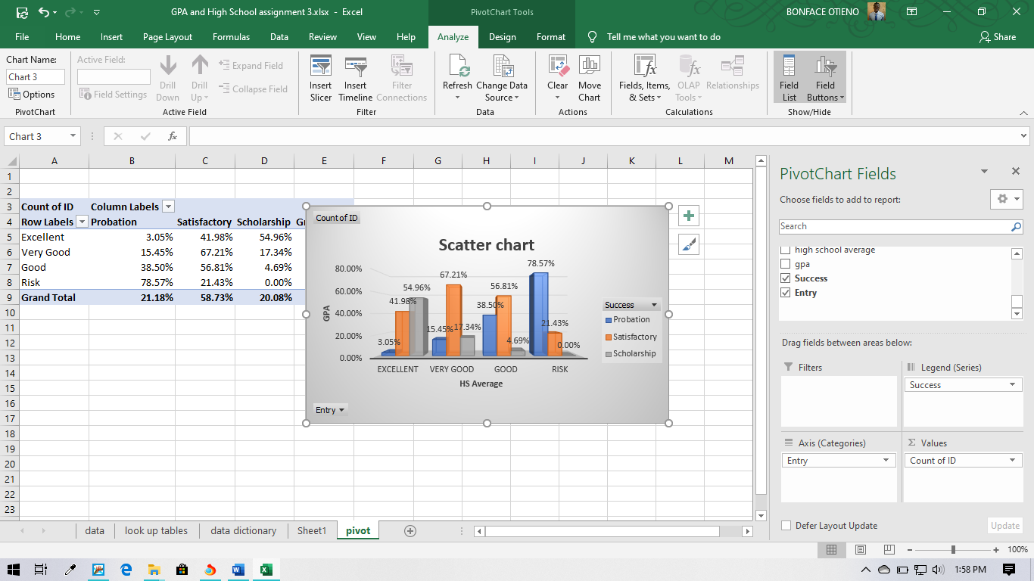
As you can see, there is a lot of noise. Although GPA is higher (on average) for those who did better in high school, there are obviously many other factors in play. How strong is this correlation? Use the Correlation function in the Data Analysis add in in Excel to measure the correlation. What is the correlation? 0.544596343
- Some believe that the best applicants apply early and late applicants are the weakest. The variable Days measures the number of days between the start of classes and the date of application. Find the correlation between Days and HS average and GPA. To use the Correlation function in Excel, the variables must be in neighboring columns. This should be the case in your file. If not, then you must move the Days column so that t is adjacent to the other two. Is there evidence that stronger students apply earlier? Justify your conclusion.
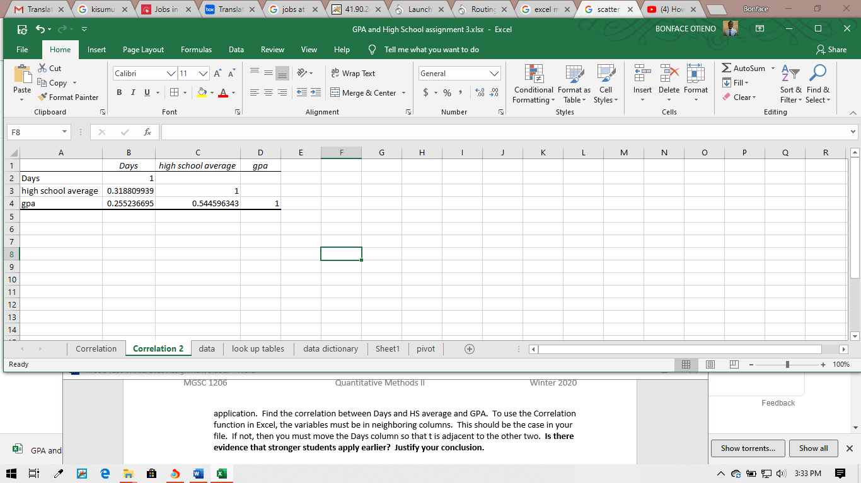
- Construct a scatter chart of days versus HS average. Right click on the vertical scale and Format the axis such that the minimum is 60 and the maximum is 100. You will get some anomalies on the horizontal axis with some unusual application dates. Many would feel that the correlation coefficient is quite large. Comment on how strong you feel the pattern is. Print your scatter chart. 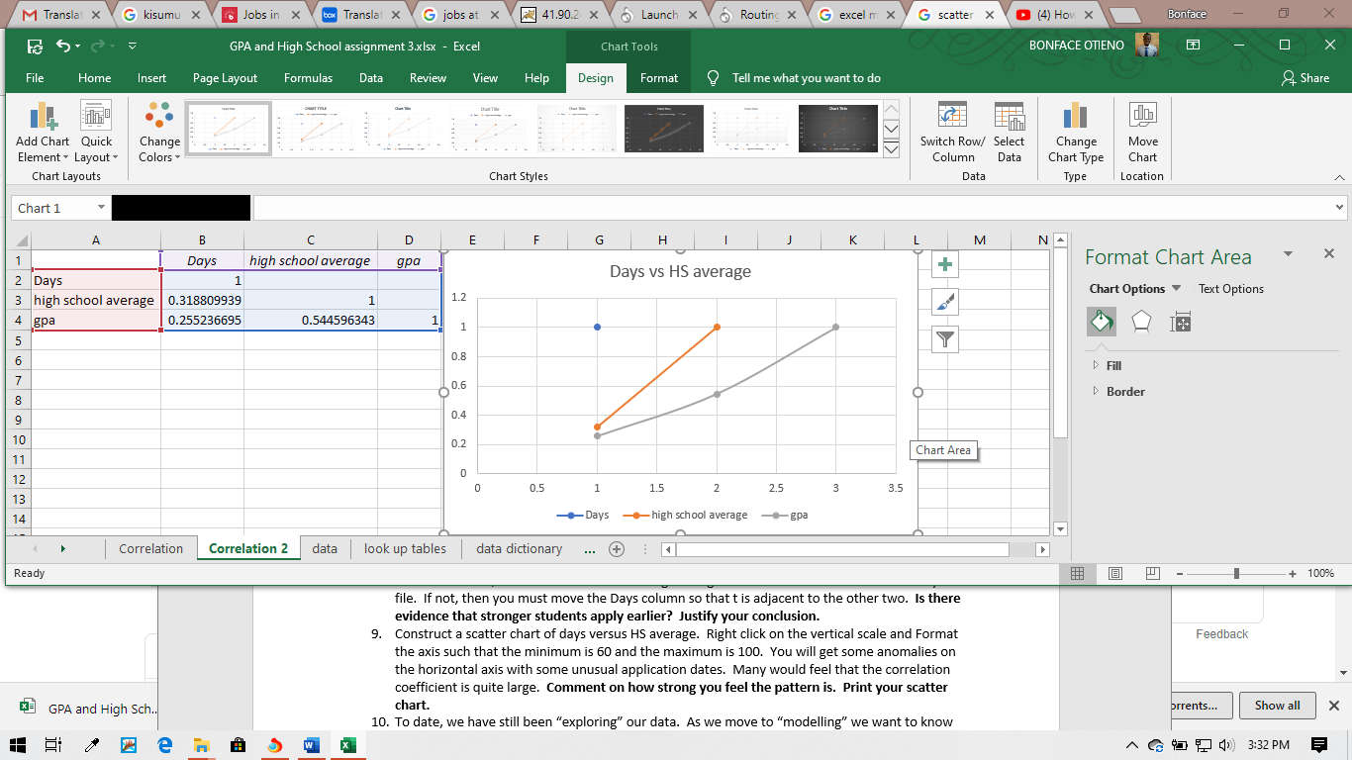
- To date, we have still been “exploring” our data. As we move to “modelling” we want to know how to predict student success (value estimation) and to be able to explain why they are successful (Causal modelling). Use the Regression function in Data Analysis in Excel to fit the linear relationship between GPA and HS Average. What is the equation of the line?
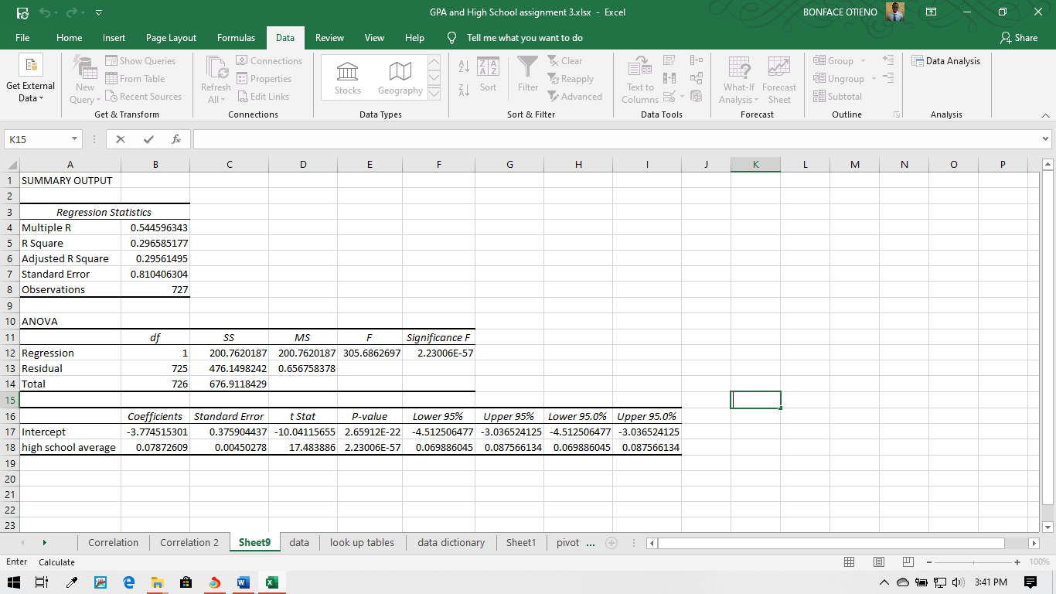
- The equation of the line has a slope and an intercept. Explain the meaning of the slope.
- The intercept is more challenging to explain. It represents the expected GPA when a student has a high school average of zero. This doesn’t happen. The lowest entering average cannot be below 60 for a student on special admission terms. What is this student’s expected GPA? 2.65
- If we wish to admit no student whose expected GPA was below 2.00, what average should we set as a minimum for admission? 2.23
- If your institutional mission includes accessibility (Saint Mary’s College was created because Irish Catholics were not allowed access to education), should we set the minimum entry average at the value you found in 14? 2.23

